# RESULTS

*Figure 2. Bioarea (proxy for biomass) in patches of the same volume but that are either connected to a patch of the same size (blue, small patches connected to other small patches) or to a patch of larger size (green, small patches connected to large patches). Boxplots display ….. For clarity, only the low disturbance treatment is shown here. See the Appendix for equivalent the figure of the high disturbance treatment.*

*Figure 3. Bioarea (proxy for biomass) in meta-ecosystems of the same total volume, but whose two patches have either the same size (red, medium-medium meta-ecosystem) or that have a smaller and larger patch (blue, small-large meta-ecosystem). Boxplots display …. For clarity, only the low disturbance treatment is shown here. See the Appendix for equivalent the figure of the high disturbance treatment.*

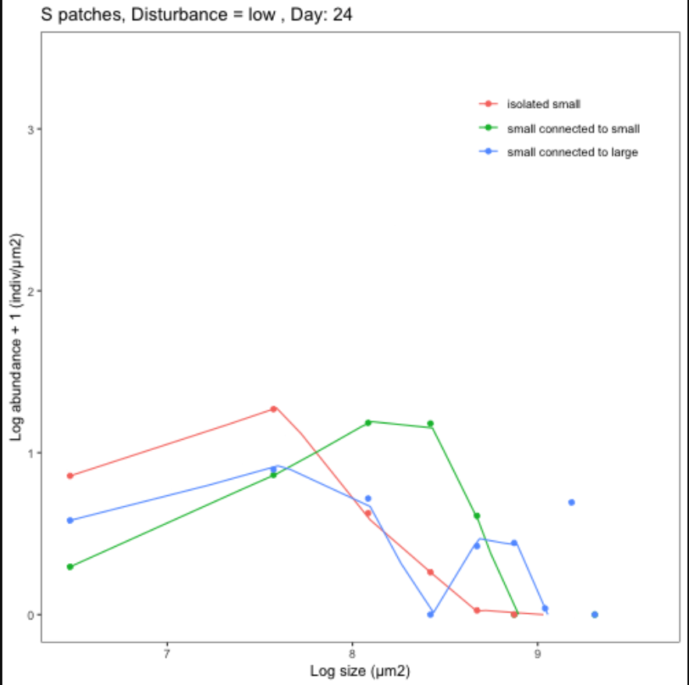

*Figure 4.*

We’ll need here also some biodiversity results but we shouldn’t go over them too much into detail otherwise we’ll draw away the attention from the meta-ecosystem structure.

# Bibliography

Carrara, F., Rinaldo, A., Giometto, A., & Altermatt, F. (2014). Complex interaction of dendritic connectivity and hierarchical patch size on biodiversity in river-like landscapes. *American Naturalist*, *183*(1), 13–25. https://doi.org/10.1086/674009

Hanski, I., Pakkala, T., Kuussaari, M., & Lei, G. (1995). Metapopulation Persistence of an Endangered Butterfly in a Fragmented Landscape. *Oikos*, *72*(1), 21. https://doi.org/10.2307/3546033

Hertzog, L. R., Boonyarittichaikij, R., Dekeukeleire, D., de Groote, S. R. E., van Schrojenstein Lantman, I. M., Sercu, B. K., … Baeten, L. (2019). Forest fragmentation modulates effects of tree species richness and composition on ecosystem multifunctionality. *Ecology*, *100*(4), 1–9. https://doi.org/10.1002/ecy.2653

Holenstein, K., Harvey, E., & Altermatt, F. (2022). Patch size distribution affects species invasion dynamics in dendritic networks. *Oikos*, *2022*(1), 1–11. https://doi.org/10.1111/oik.08679

Liu, J., Wilson, M., Hu, G., Liu, J., Wu, J., & Yu, M. (2018). How does habitat fragmentation affect the biodiversity and ecosystem functioning relationship? *Landscape Ecology*, *33*(3), 341–352. https://doi.org/10.1007/s10980-018-0620-5

MacArthur, R. H., & Wilson, E. O. (1963). An Equilibrium Theory of Insular Zoogeography. *Evolution*, *17*(4), 373. https://doi.org/10.2307/2407089

Marleau, J. N., Guichard, F., & Loreau, M. (2014). Meta-ecosystem dynamics and functioning on finite spatial networks. *Proceedings of the Royal Society B: Biological Sciences*, *281*(1777). https://doi.org/10.1098/rspb.2013.2094

Spiecker, B., Gouhier, T. C., & Guichard, F. (2016). Reciprocal feedbacks between spatial subsidies and reserve networks in coral reef meta-ecosystems. *Ecological Applications*, *26*(1), 264–278. https://doi.org/10.1890/15-0478.1/suppinfo